Supplemental Materials

Long-lasting Farside Volcanism in the Apollo Basin: Chang’e-6 Landing Site

Yuqi Qian^{1*}, James Head², Joseph Michalski^{1*}, Xing Wang^{2,3}, Carolyn van der Bogert⁴, Harald Hiesinger⁴, Lingzhi Sun⁵, Wei Yang⁶, Long Xiao⁷, Xianhua Li⁶, Guochun Zhao¹

¹Department of Earth Sciences & Laboratory for Space Research & NWU-HKU Joint Center of Earth and Planetary Sciences, The University of Hong Kong, Hong Kong, China
²Department of Earth, Environmental and Planetary Sciences, Brown University, Providence, RI, USA
³Key Laboratory of Lunar and Deep Space Exploration, National Astronomical Observatories, Chinese Academy of Sciences, Beijing, China
⁴Institut für Planetologie, Universität Münster, Münster, Germany
⁵Hawai‘i Institute of Geophysics and Planetology, University of Hawai‘i at Mānoa, Honolulu, HI, USA
⁶Key Laboratory of Earth and Planetary Physics, Institute of Geology and Geophysics, Chinese Academy of Sciences, Beijing, China
⁷Planetary Science Institute, School of Earth Sciences, China University of Geosciences, Wuhan, China

Corresponding author: Yuqi Qian (yuqiqian@hku.hk), Joseph Michalski (jmichal@hku.hk)

Text S1. Hapke Radiative Transfer Model
We followed Sun and Lucey (2021)’s approach to constrain the mineral abundance of a Moon Mineralogy Mapper (M³) spectrum collected in the study area. The reflectance factor of a spectrum was calculated by the Hapke radiative transfer model (Hapke, 2012), $r(i, e, g)=\frac{Kω}{4(μ_{0}+μ)}\left\{\left[1+B\left(g\right)\right]P\left(g\right)+H\left(μ_{0}/K\right)H\left(μ/K\right)-1\right\}$, where $μ_{0}=cos⁡(i)$, $μ=cos⁡(e)$, $g$, $i$, and $e$ are phase ($g=30°$), incidence ($i=30°$), and emission angles ($e=0°$), respectively. $K$ is porosity coefficient and $K=-\frac{\ln\left(1-1.209φ^{2/3}\right)}{1.209φ^{2/3}}$; $φ$ is filling factor and was set to be 0.41 (Hapke, 1986). $B(g)$ is the backscatter function and $B\left(g\right)=\frac{h_{s}}{h_{s}+tan(g/{2)}}$, where $h_{s}=0.0636$. $P(g)$ is the phase function and $P\left(g\right)=1+bcos\left(g\right)+c(1.5\cos^{2}\left(g\right)-0.5)$, where $b=-0.4, c=0.25$(Mustard and Pieters, 1989). $H\left(μ,ω\right)$ is the Ambartsumian-Chandrasekar H function and $H\left(μ,ω\right)={\left[1-ωμ(r_{0}+\frac{1-2r_{0}μ}{2}ln⁡(\frac{1+μ}{μ})\right]}^{-1}$, where $r_{0}=\frac{1-\sqrt{1-ω}}{1+\sqrt{1-ω}}$. $ω$ is single scattering albedo and is expressed by the equivalent slab model (Hapke, 2012), $ω=S_{e}+(1-S_{e})(1-S_{i})\frac{Θ}{1-S_{i}Θ}$. The external surface scattering coefficient $S_{e}=\frac{{(n-1)}^{2}+k^{2}}{{\left(n+1\right)}^{2}+k^{2}}+0.05$ and the internal surface scattering coefficient $S_{i}=1.014-\frac{4}{n{\left(n+1\right)}^{2}}$. $n$ and $k$ are the real and imaginary parts of the refractive index. $Θ$ is the internal-transmission factor and $Θ=e^{-α<D>}$, where $α$ is the absorption coefficient; $<D>$ is the thickness of the equivalent slab and $<D>=\frac{2}{3}\left[n^{2}-\frac{1}{n}{\left(n^{2}-1\right)}^{3/2}\right]D$.
Four major minerals were included in the spectral lookup table: three mafic minerals (CPX, OPX, OLV) are mixed within 0-100 vol% at 10 vol% intervals and then mixed with 0-100 vol% PLG at 2 vol% intervals. SMFe was set to be 0.5, 1, 2, 3, 4, 5, 7, and Mg# was set between 40-90 at intervals of 5. In total, a spectral library of 254177 spectra was constructed. To search the best-fit spectra from the lookup table to the investigated M³ spectra after continuum removal, a CR value ($CR=0.8×RMS+0.2 ×(1-\left|R\right|)$) was used, where the best-fit spectrum has the smallest CR value. The FeO content of the M³ spectra was calculated by the method of Lemelin et al. (2015). In an assessment, the difference in FeO between the M³ spectra and the synthesized spectra was limited within 2 wt.%.

Text S2. Crater Excavation Technique
The crater excavation technique (Chen et al., 2018) was used to constrain the thickness of high-Ti basalts in the Southern Mare between the peak ring and rim crest of the Apollo basin (Fig. 5), which overlies the older low-Ti basalts. Because a large enough crater could penetrate through the superposed high-Ti basalts and bring up low-Ti materials, we identified and assessed penetrating (low-Ti ejecta) and non-penetrating (high-Ti ejecta) craters in the Kaguya TiO₂ maps (Fig. S9). For each spot constrained by the crater excavation technique, the mare thickness is smaller than the excavation depth of a penetrating crater because only low-Ti materials would be excavated; and mare thickness is larger than the excavation depth of a non-penetrating crater, because otherwise low-Ti materials would be excavated. Therefore, for a region between a penetrating crater and a non-penetrating crater, the mare thickness is in the range of the upper limit set by penetrating craters and the lower limit set by non-penetrating craters. In this study, the excavation depth of a crater is calculated by the relation proposed by Melosh (1989), where $H_{exc}=0.1 D_{t}, D_{t}=0.84 D$, $H_{exc}$ is the excavation depth of a crater, $D_{t}$ is the transient crater diameter, and $D$ is the diameter of the crater measured.

Data S1. Crater Counting Files. The crater counting files used to fit CSFD curves in this study. This file (“Data S1. Crater Counting Files.7z”) is attached separately in the supplemental materials.

Table S1. Comparison between CSFD model ages obtained in this study and those reported by other studies (Greeley et al., 1993; Haruyama et al., 2009; Pasckert et al., 2018; Zeng et al., 2023).
THIS STUDY  CF: Yue et al. (2022) |  | Greeley et al. (1993)  CF: Neukum (1983) |  | Haruyama et al. (2009)  CF: Neukum (1983) |  | Pasckert et al. (2018)  CF: Neukum et al. (2001) |  | Zeng et al. (2023)  CF: Neukum (1983)
Unit | Age (Ga) | Unit | Age (Ga) | Unit | Age (Ga) | Unit | Age (Ga) | Unit | Age (Ga)
Northwestern Mare | $${1.79}_{-0.26}^{+0.26}$$ | Apollo Maria | $${3.63}_{-0.06}^{+0.05}$$ |  |  | Ap7 | $${2.40}_{-0.32}^{+0.31}$$
Central Mare | $${2.01}_{-0.10}^{+0.10}$$ | Apollo Maria | $${3.63}_{-0.06}^{+0.05}$$ | Apollo N | 2.49/3.51 | Ap1 | $${2.93}_{-0.07}^{+0.07}$$
Western Mare | $${2.12}_{-0.14}^{+0.14}$$ | Apollo Maria | $${3.63}_{-0.06}^{+0.05}$$ |  |  | Ap6 | $${3.39}_{-0.02}^{+0.02}$$
Southeastern  Mare | $${2.72}_{-0.24}^{+0.20}$$ | Apollo Maria | $${3.63}_{-0.06}^{+0.05}$$ |  |  | Ap3 | $${3.38}_{-0.07}^{+0.05}$$
Southern  Mare 1 | $${3.07}_{-0.08}^{+0.07}$$ | Apollo Maria | $${3.63}_{-0.06}^{+0.05}$$ | Apollo S | 2.44 | Ap4 | $${3.31}_{-0.02}^{+0.02}$$ | F | $${2.40}_{-0.11}^{+0.11}$$
Southern  Mare 2 | $${3.34}_{-0.06}^{+0.04}$$ |  |  |  |  | Ap5 | $${3.45}_{-0.05}^{+0.04}$$ | L | $${3.43}_{-0.06}^{+0.04}$$
Cryptomare
Type 1 Area
Cryptomare  Type 2 Area | $${4.05}_{-0.01}^{+0.01}$$ |  |  |  |  |  |  | B | $${3.86}_{-0.05}^{+0.04}$$

Table S2. CSFD model ages of mare units using the chronology function of Neukum et al. (2001) and the cumulative fit method, in comparison with the results reported by Pasckert et al. (2018).
 | THIS STUDY  CF: Neukum et al. (2001) |  |  |  | Pasckert et al. (2018)  CF: Neukum et al. (2001)
Unit | Count Area (km²) | Count Craters | N(1) (km⁻²) | Age (Ga) | Unit | Count Area (km²) | Count Craters | N(1) (km⁻²) | Age (Ga)
Northwestern Mare | 56 | 48 | 1.33×10⁻³ | $${1.58}_{-0.23}^{+0.23}$$ | Ap7 | 144 | 55 | 2.01×10⁻³ | $${2.40}_{-0.32}^{+0.31}$$
Central Mare | 746 | 377 | 1.63×10⁻³ | $${1.95}_{-0.09}^{+0.09}$$ | Ap1 | 4460 | 1041 | 2.49×10⁻³ | $${2.93}_{-0.07}^{+0.07}$$
Western Mare | 395 | 230 |  | $${2.02}_{-0.13}^{+0.13}$$ | Ap6 | 2090 | 668 | 3.69×10⁻³ | $${3.39}_{-0.02}^{+0.02}$$
Southeastern  Mare | 44 | 111 | 2.02×10⁻³ | $${2.41}_{-0.23}^{+0.22}$$ | Ap3 | 378 | 86 | 3.66×10⁻³ | $${3.38}_{-0.07}^{+0.05}$$
Southern  Mare 1 | 1845 | 488 | 2.25×10⁻³ | $${2.68}_{-0.13}^{+0.13}$$ | Ap4 | 4060 | 1244 | 3.26×10⁻³ | $${3.31}_{-0.02}^{+0.02}$$
Southern  Mare 2 | 517 | 166 | 3.08×10⁻³ | $${3.26}_{-0.10}^{+0.06}$$ | Ap5 | 1500 | 86 | 4.16×10⁻³ | $${3.45}_{-0.05}^{+0.04}$$
Cryptomare
Type 1 Area
Cryptomare  Type 2 Area | 10456 | 222 | 8.52×10⁻² | $${4.05}_{-0.01}^{+0.01}$$

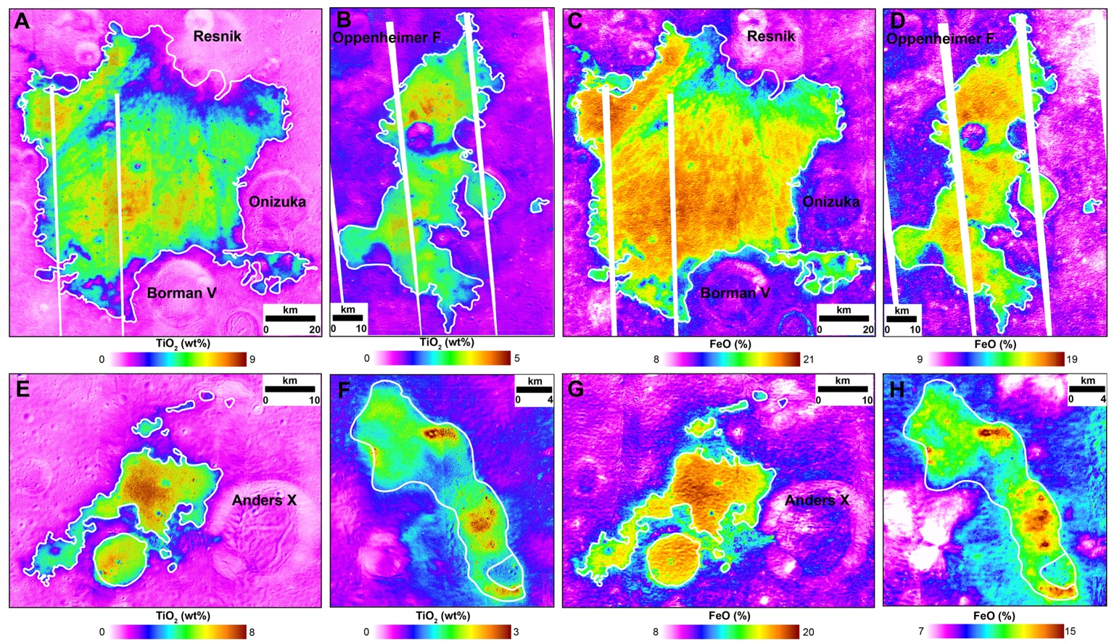

Fig. S1. Kaguya Multiband Imager (MI) TiO₂ and FeO abundance of mare units within the Apollo basin. (A, C) Central Mare. (B, D) Western Mare. (E, G) Southeastern Mare. (F, H) Northwestern Mare.

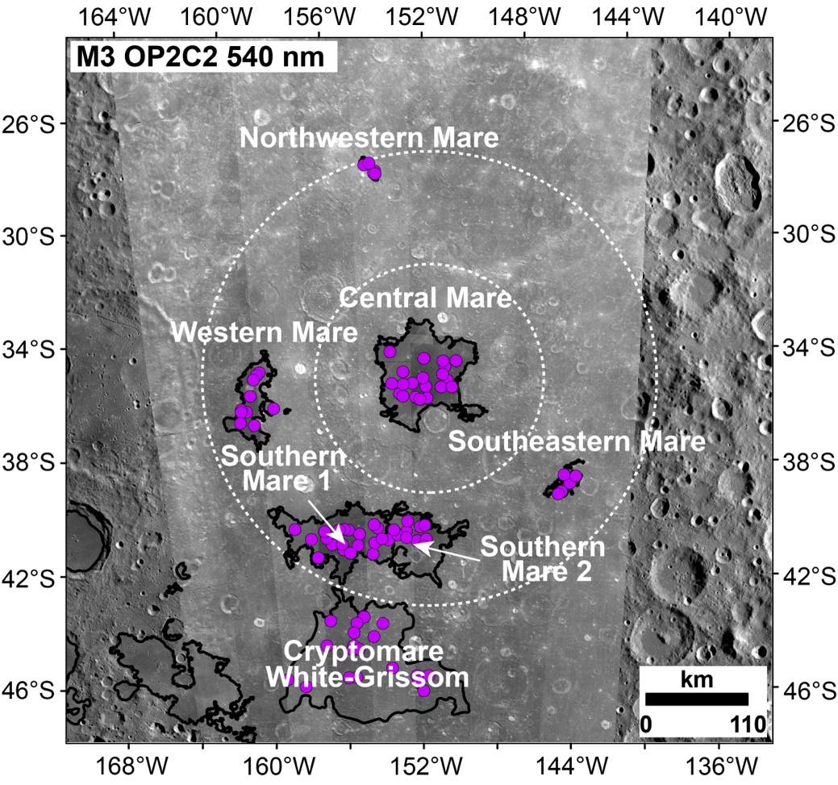

Fig. S2. M³ spectrum extraction points (purple points) within the study area. The basemap is M³ OP2C2 data overlaying on the LROC WAC image. Detailed information on each extracted spectrum is available in Table S2. M³ List and Table S3. M³ Data.

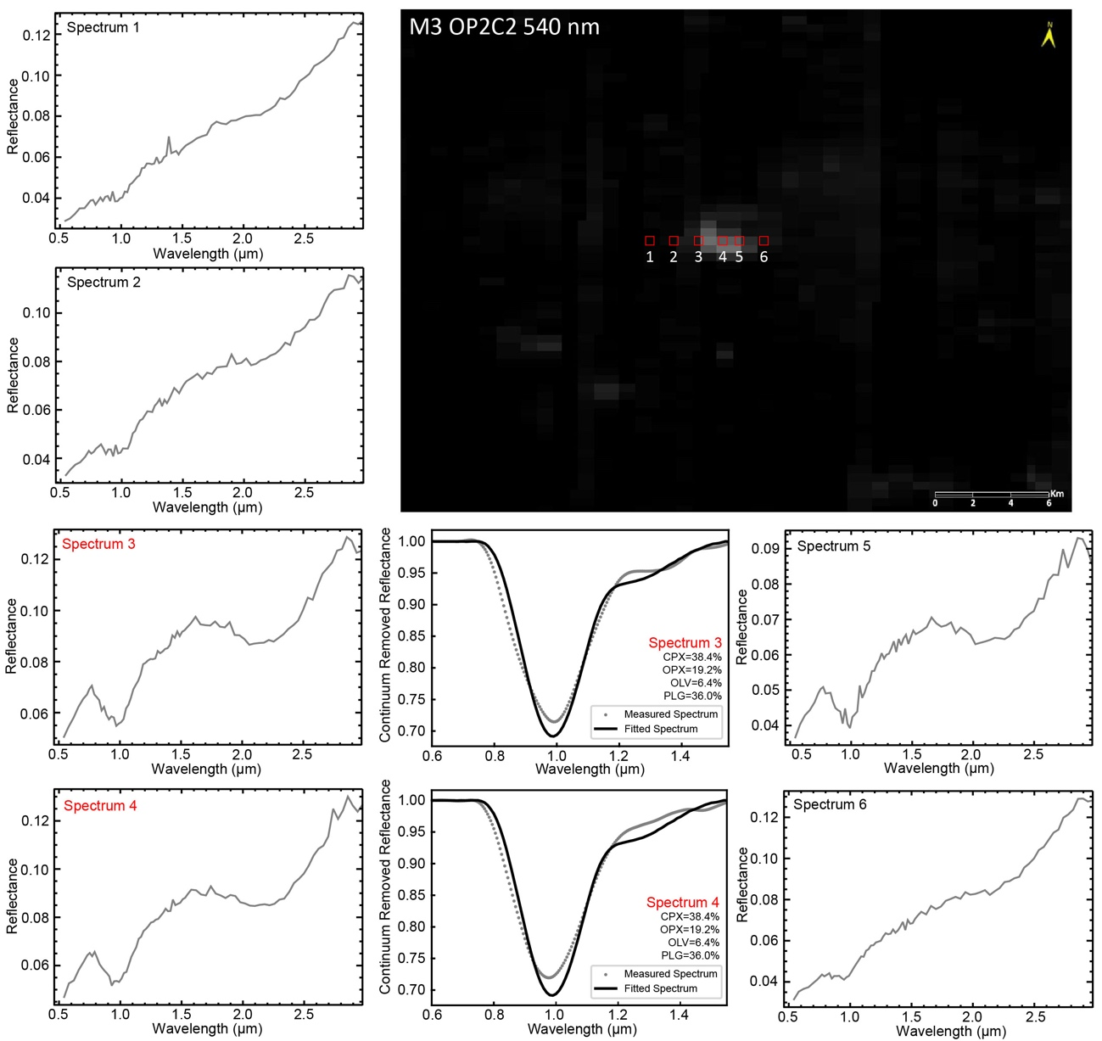

Fig. S3. An example of how to select representative spectra from small-fresh craters. Only spectra from small-fresh craters were extracted to acquire data with high signal-to-noise ratio that are less impacted by space weathering effects and less contaminated by exotic ejecta. In this example, Spectrum 1-6 were extracted across a small-fresh crater with a diameter of ~850 m. Spectrum 3 and 4, with the highest reflectance, represent well the surface mineralogy of the mare unit close to this small-fresh crater, with nearly identical absorptions and modeled mineral abundances; therefore, they qualify to be used in this study. Other spectra have a large noise level due to space weathering effects that are not suitable for Hapke modeling, even after smoothing and continuum removal. Extracting the spectra of the entire mare units would inevitably include areas that are heavily space weathered (most of the area) or covered by exotic impact ejecta (e.g, bright rays, Fig. 2A). Thus, only representative spectra of small-fresh craters were extracted to avoid space weathering and exotic material effects and obtain high confidence level mineralogy of mare units via Hapke modeling, following the approach of Sun and Lucey (2021) (Details in Text S1).

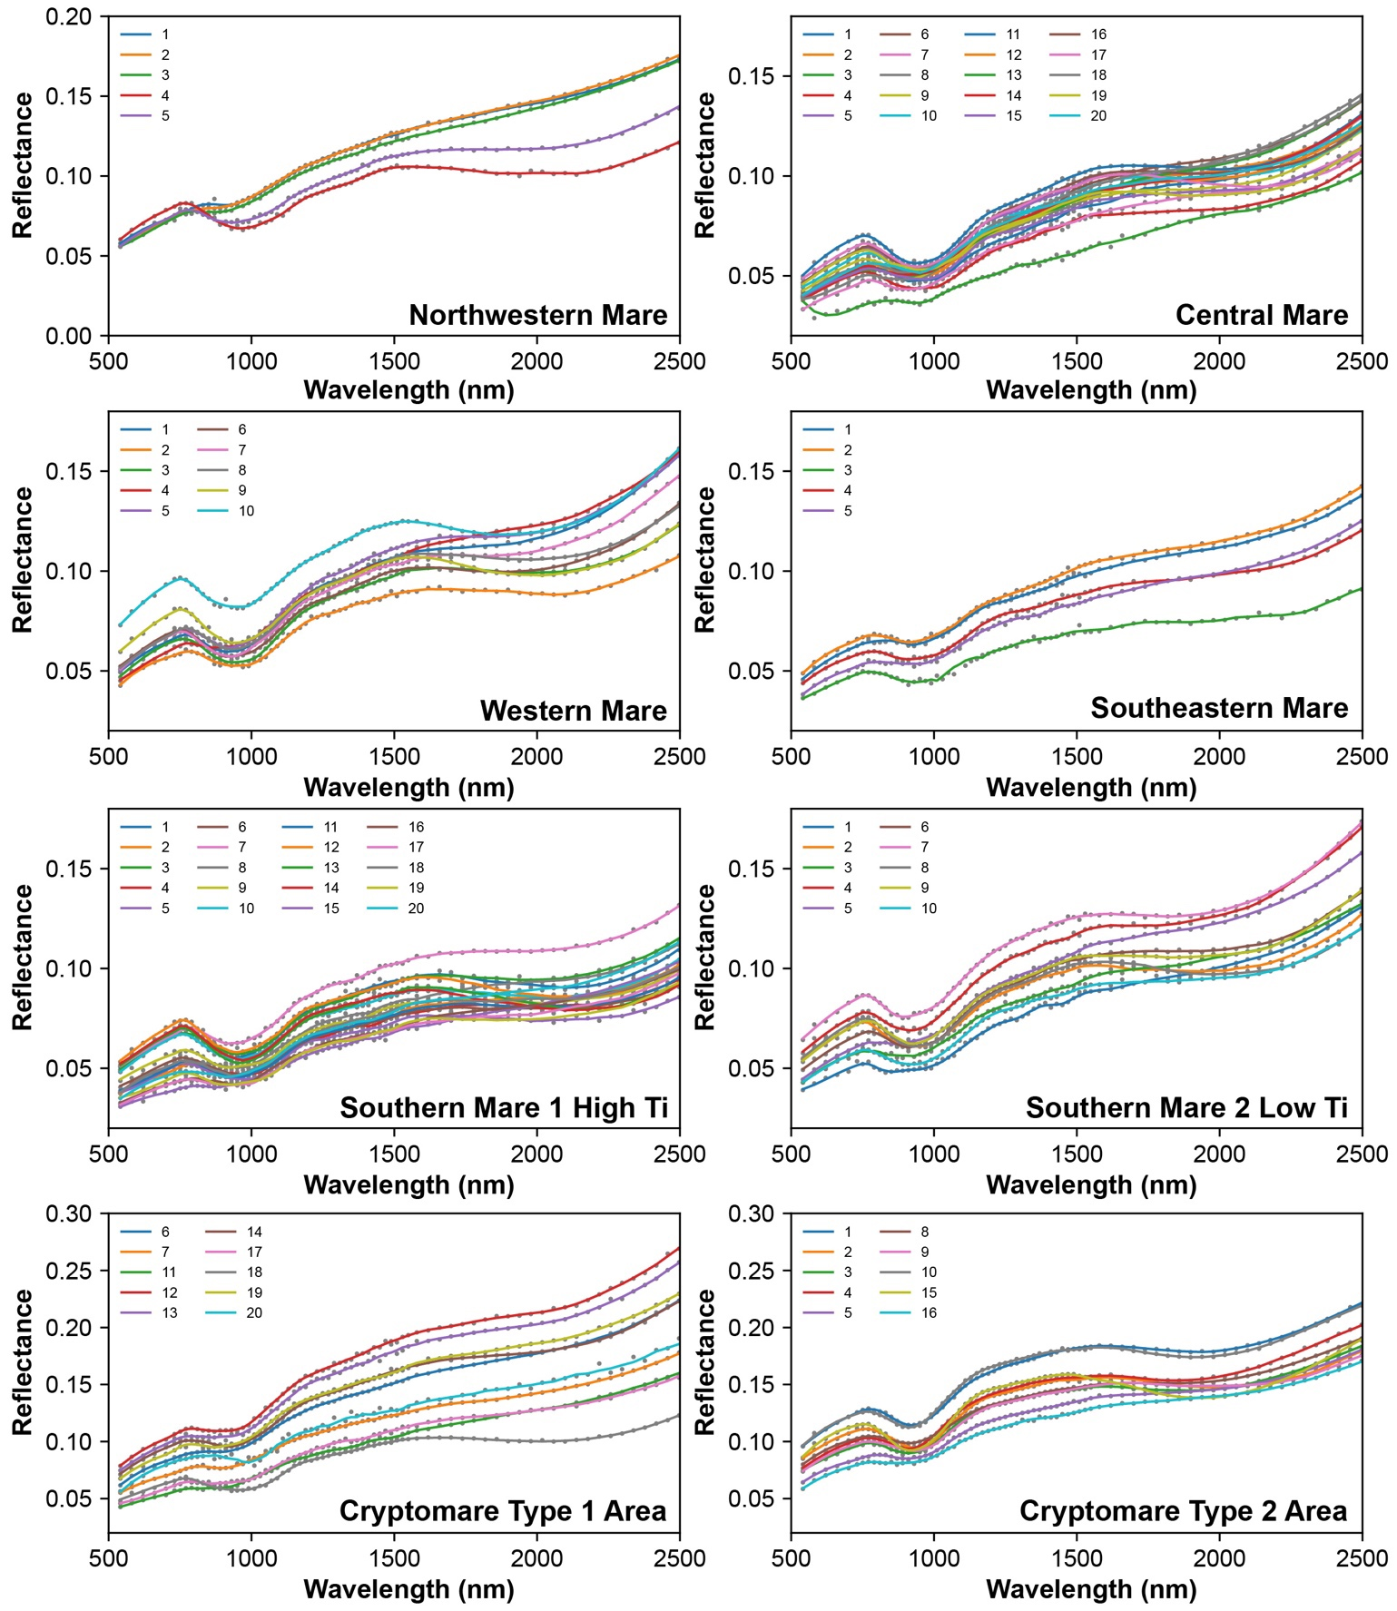

Fig. S4. M³ spectra extracted from small-fresh craters for each mare unit. Detailed information on each extracted spectrum is available in Table S2. M³ List and Table S3. M³ Data.

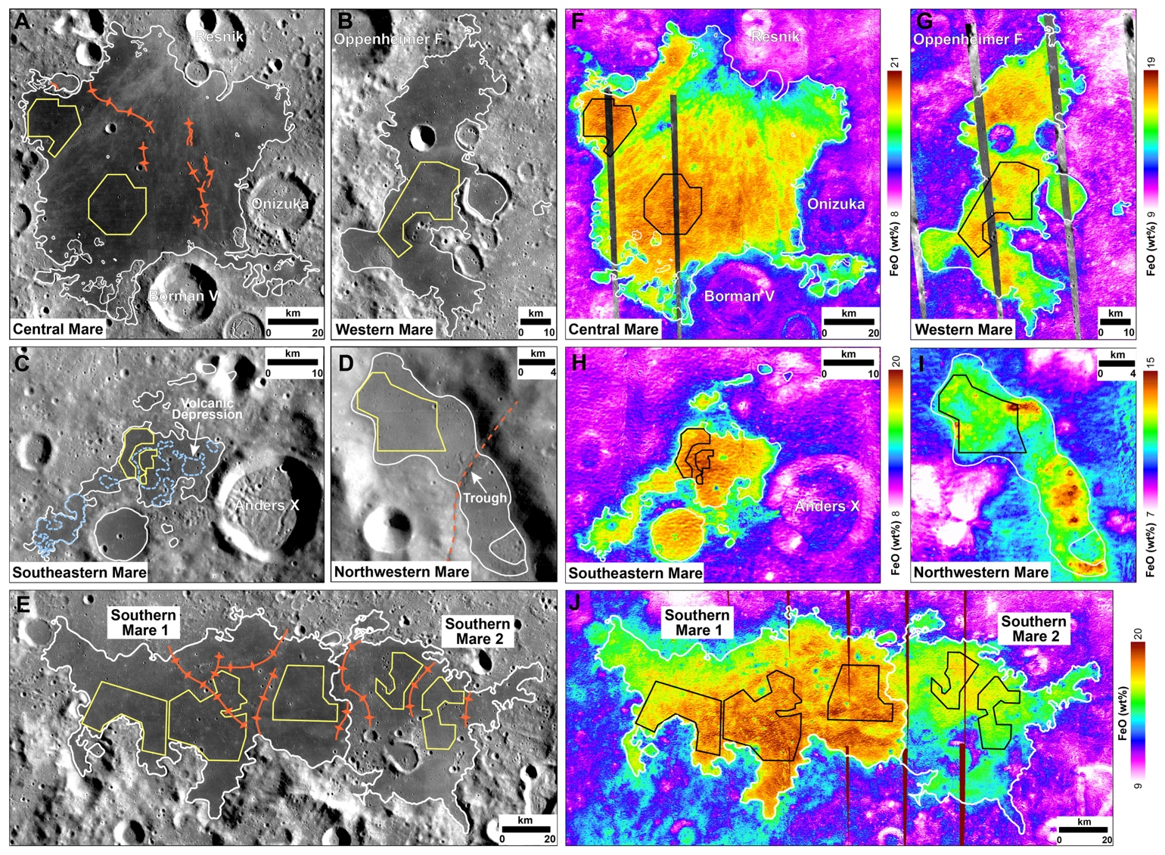

Fig. S5. Crater counting areas for mare units in the Apollo basin. (A, F) Central Mare. (B, G) Western Mare. (C, H) Southeastern Mare. (D, I) Northwestern Mare. (E, J) Southern Mare. The white lines indicate mare boundaries. The yellow/black polygons represent crater-counting areas. They were selected away from major ejecta rays, secondary craters, wrinkle ridges, and volcanic landforms (mesas, domes, depressions).

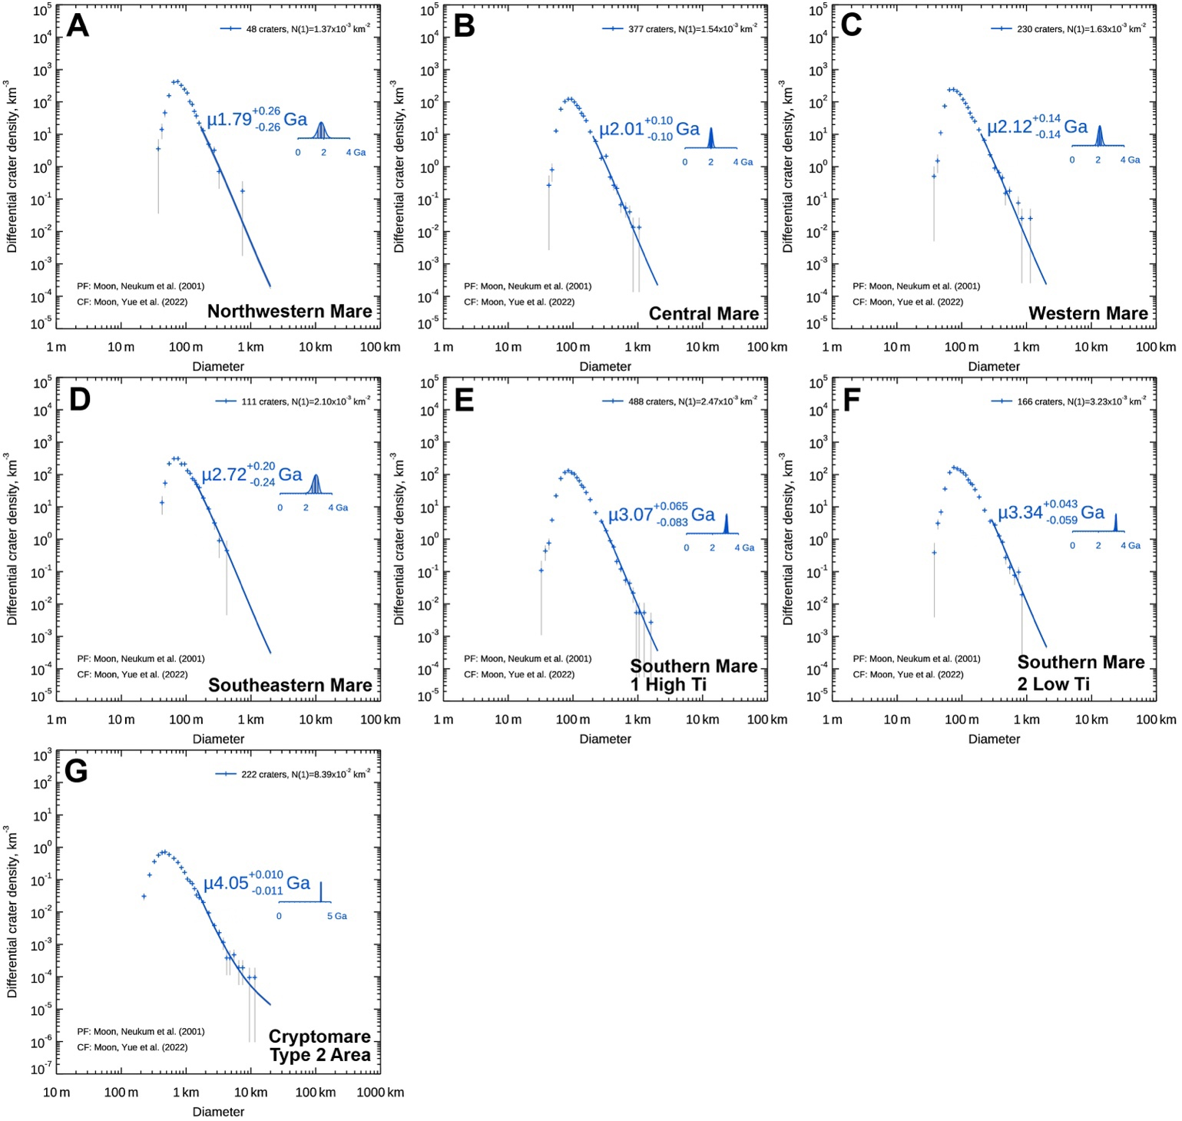

Fig. S6. Crater size-frequency distribution measurement results for all mare unit. Crater counting areas are shown in Fig. S5.

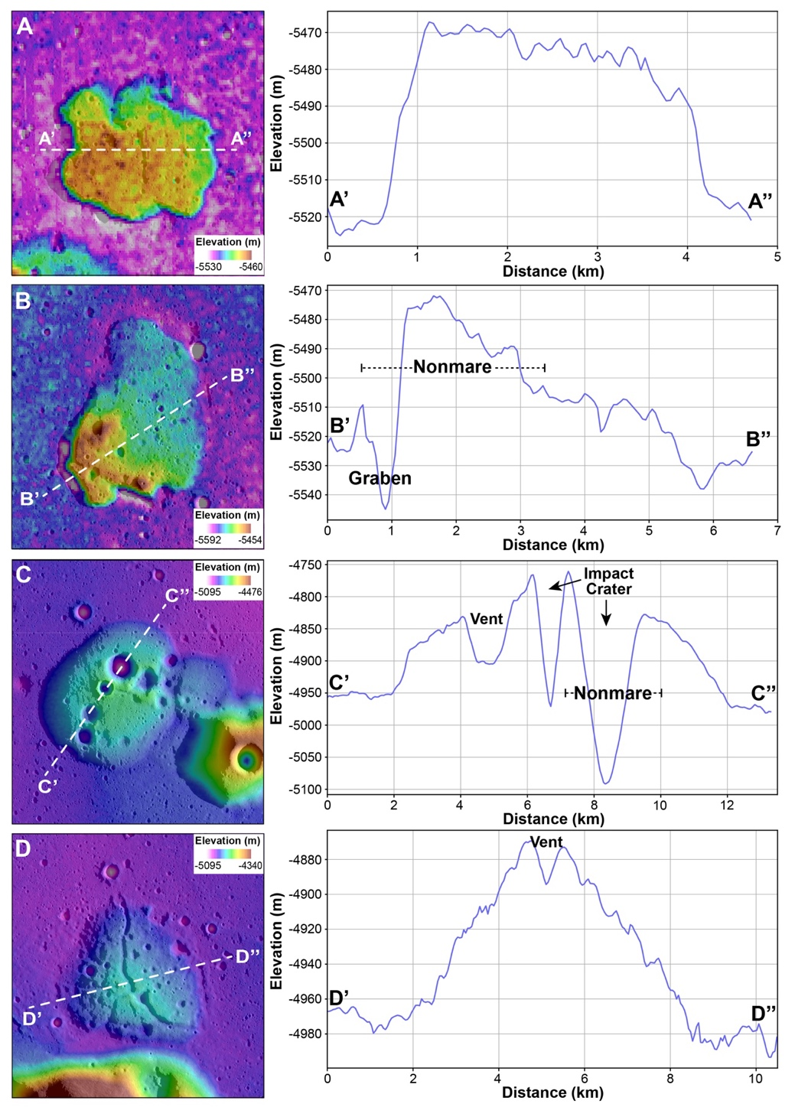

Fig. S8. Topographic profiles of volcanic mesas and domes in Central Mare and Western Mare, respectively. The elevation data is based on SLDEM2015. The profile lines are shown as white dashed lines.

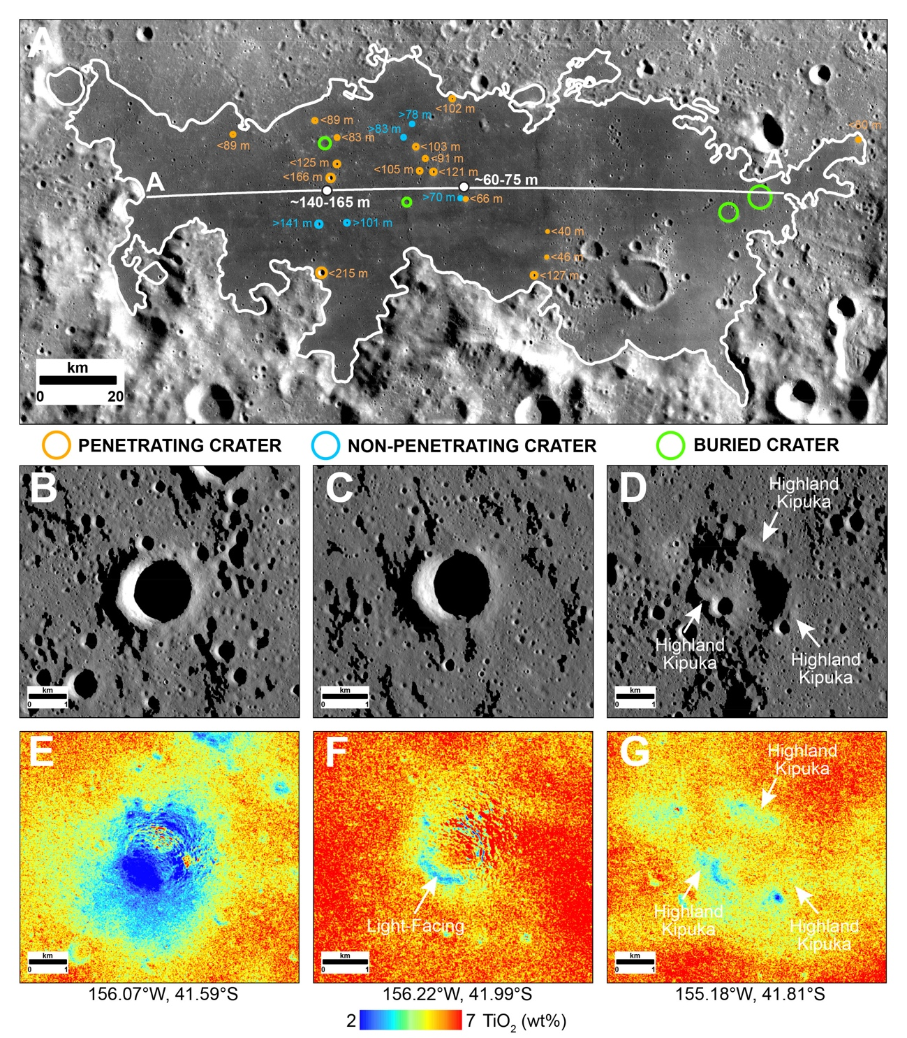

Fig. S9. Mare thickness of the Southern Mare unit obtained by the crater excavation technique. (A) Distribution of penetrating, non-penetrating, and buried craters. (B, E) An example of a penetrating crater with low-Ti ejecta deposit. (C, F) An example of a non-penetrating crater with a high-Ti ejecta deposit. The low-Ti values at this crater's southwestern rim are abnormal due to facing the illumination direction. (D, G) An example of a buried crater with an exposed low-Ti rim. This crater formed at the base of the Apollo basin, and area that is composed of highland materials. It was later buried by mare eruptions that flowed over this crater, leaving highland kipukas.

Reference
Chen, Y., Li, C., Ren, X., Liu, J., Wu, Y., Lu, Y., Cai, W., Zhang, X., 2018. The Thickness and Volume of Young Basalts Within Mare Imbrium. J. Geophys. Res. Planets 123, 630–645. https://doi.org/10.1002/2017JE005380
Greeley, R., Kadel, S.D., Williams, D.A., Gaddis, L.R., Head, J.W., McEwen, A.S., Murchie, S.L., Nagel, E., Neukum, G., Pieters, C.M., Sunshine, J.M., Wagner, R., Belton, M.J.S., 1993. Galileo imaging observations of lunar maria and related deposits. J. Geophys. Res. Planets 98, 17183–17205. https://doi.org/10.1029/93JE01000
Hapke, B., 2012. Theory of Reflectance and Emittance Spectroscopy, 2nd ed. Cambridge University Press, Cambridge. https://doi.org/DOI: 10.1017/CBO9781139025683
Hapke, B., 1986. Bidirectional reflectance spectroscopy: 4. The extinction coefficient and the opposition effect. Icarus 67, 264–280. https://doi.org/10.1016/0019-1035(86)90108-9
Haruyama, J., Ohtake, M., Matsunaga, T., Morota, T., Honda, C., Yokota, Y., Abe, M., Ogawa, Y., Miyamoto, H., Iwasaki, A., Pieters, C.M., Asada, N., Demura, H., Hirata, N., Terazono, J., Sasaki, S., Saiki, K., Yamaji, A., Torii, M., Josset, J.-L., 2009. Long-Lived Volcanism on the Lunar Farside Revealed by SELENE Terrain Camera. Science 323, 905.
Lemelin, M., Lucey, P.G., Song, E., Taylor, G.J., 2015. Lunar central peak mineralogy and iron content using the Kaguya Multiband Imager: Reassessment of the compositional structure of the lunar crust. J. Geophys. Res. Planets 120, 869–887. https://doi.org/10.1002/2014JE004778
Melosh, H.J., 1989. Impact cratering : a geologic process, New York : Oxford University Press ; Oxford : Clarendon Press.
Mustard, J.F., Pieters, C.M., 1989. Photometric phase functions of common geologic minerals and applications to quantitative analysis of mineral mixture reflectance spectra. J. Geophys. Res. Solid Earth 94, 13619–13634. https://doi.org/10.1029/JB094iB10p13619
Neukum, G., Ivanov, B.A., Hartmann, W.K., 2001. Cratering Records in the Inner Solar System in Relation to the Lunar Reference System, in: Kallenbach, R., Geiss, J., Hartmann, William K (Eds.), Chronology and Evolution of Mars. Springer Netherlands, Dordrecht, pp. 55–86.
Pasckert, J.H., Hiesinger, H., van der Bogert, C.H., 2018. Lunar farside volcanism in and around the South Pole–Aitken basin. Icarus 299, 538–562. https://doi.org/10.1016/j.icarus.2017.07.023
Sun, L., Lucey, P.G., 2021. Unmixing Mineral Abundance and Mg# With Radiative Transfer Theory: Modeling and Applications. J. Geophys. Res. Planets 126, e2020JE006691. https://doi.org/10.1029/2020JE006691
Zeng, X., Liu, D., Chen, Y., Zhou, Q., Ren, X., Zhang, Z., Yan, W., Chen, W., Wang, Q., Deng, X., Hu, H., Liu, J., Zuo, W., Head, J.W., Li, C., 2023. Landing site of the Chang’e-6 lunar farside sample return mission from the Apollo basin. Nat. Astron. https://doi.org/10.1038/s41550-023-02038-1

